**PRACTICE #03 – Scikit-learn with PCA & LDA**

Multivariate Statistical Analysis – 19TGMT



**Teacher:**

* PhD. Lý Quốc Ngọc
* MS. Nguyễn Mạnh Hùng
* MS. Phạm Thanh Tùng

**Student:**

* Chung Kim Khánh (19127644)

**Table of content**

I. INFORMATION 2

II. DESCRIBE THE DATA INFORMATION 2

III. SOME BASIC MULTIVARIATE ANALYSIS WITH VISUALIZATION 9

IV. PCA & LDA 11

V. REFERENCE 18

# INFORMATION

|  |  |  |
| --- | --- | --- |
| student id | fullname | MAil |
| 19127644 | Chung Kim Khánh | ckkhanh19@clc.fitus.edu.vn |

# DESCRIBE THE DATA INFORMATION

The data is the results of a chemical analysis of wines grown in the same region in Italy but derived from three different cultivars. The analysis determined the quantities of 13 constituents found in each of the three types of wines.

The attributes are:

1. Alcohol
2. Malic acid
3. Ash
4. Alcalinity of ash
5. Magnesium
6. Total phenols
7. Flavanoids
8. Nonflavanoid phenols
9. Proanthocyanins
10. Color intensity
11. Hue
12. OD280/OD315 of diluted wines
13. Proline

All attributes are continuous. The 1st attribute is the class identifier (1-3).

## Read data from the given sample CSV file

The output:

## Describe the data information

Plot data for visualization



Scatterplot with the data points labelled by their Group



Profile plot, used to shows the variation in each of the variables, by plotting the value of each of the variables for each of the samples



# SOME BASIC MULTIVARIATE ANALYSIS WITH VISUALIZATION

Calculating summary statistics for multivariate data

The output:

* Mean

* Standard deviation

* Max

* Min

Means and variances per group

The output:

# PCA & LDA

Standardising variables

The output:

## PCA

This method is called Principal Component Analysis (PCA). This method is based on the observation that the data are not normally distributed randomly in space but are often distributed near certain special lines/surfaces. PCA considers a special case where such special faces have linear form as subspaces. PCA is an unsupervised learning method, i.e. it only uses vectors describing the data and not the labels, if any, of the data.

Apply PCA using sklearn



Check the summary of PCA results

The output:

Check how many principal components to retain

The output:

Calculate the values of the first principal component

The output:

Obtain the loadings for the second principal component



The output:

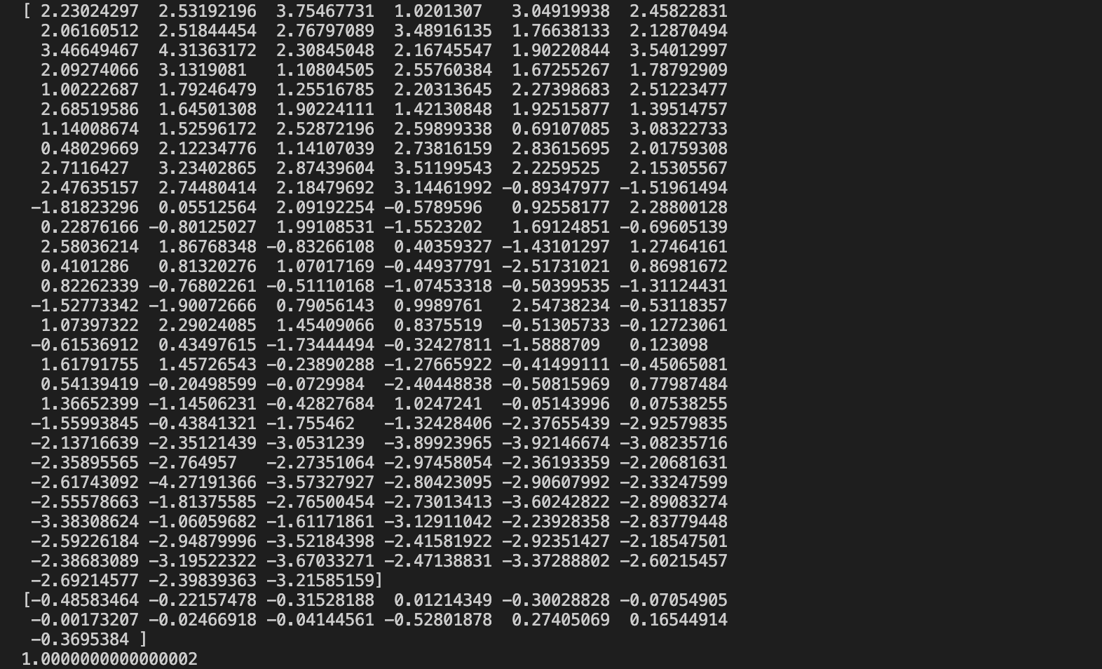

Visualize scatterplots of the principal components

The output:

Get mean, standard deviations, and sample sizes



The output:

## LDA

LDA is a data dimensionality reduction method for classification problems. LDA can be thought of as a method of dimensionality reduction, or it can be thought of as a classification method, or it can be applied simultaneously to both (i.e., reducing the data dimensionality so that the most efficient classification).

Apply LDA using sklearn (“main_LDA_2.py”)

The output:

Evaluation with Confusion matrix “main_LDA_1.py”

The output:

# REFERENCE

1. <https://machinelearningcoban.com/2017/06/15/pca/>
2. <https://machinelearningcoban.com/2017/06/30/lda/>
3. <https://github.com/Ayantika22/Linear-discriminant-Analysis-LDA-for-Wine-Dataset>
4. <https://scikit-learn.org/stable/auto_examples/decomposition/plot_pca_vs_lda.html?fbclid=IwAR2YF0CQwa3DKx0GtolPwulVjoZwmcnxyRBuvTIR2dNNa7kFN6o5CtprhFg>